English Olympiad
Grade 6

1 Choose the correct auxiliary verb: _____ Damir live near Miras?

A) Is
B) Are
C) Do
D) Does
E) Were

2 Choose the correct verb: Every year millions of people _____ the London Museum.

A) visit
B) go
C) come
D) want
E) see

3 Solve the puzzle
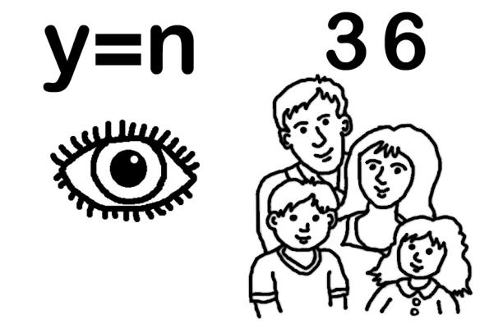

A) family
B) enemy
C) emeny
D) anemy
E) Emily

4 Choose the correct option: My friends arrived _____ two o’clock _____ the afternoon.

A) at / in
B) in / for
C) when / ago
D) last / -
E) in / at

5 The actress _____ a bright red dress at the party yesterday.

A) was wore
B) was wearing
C) wear
D) was wear
E) is wearing

6 Choose the correct reply:
- What's the weather like?
- _____. Put on your coat.
- Is it snowing?
- No, it's not but _____.

A) It's warm / it is raining
B) It's fine / it rains
C) It is bad / it is hot
D) It is nice / it rained
E) It's cold / it's going to

7 Put the following sentences in the correct order

1. I've been playing for several days now.
2. I'm mad about computer games and can't live without them.
3. Some computer games are very expensive.
4. I usually play for about two hours a day.
5. That's why I can't buy the ones I want.

A) 5, 1, 4, 3, 2
B) 2, 4, 1, 3, 5
C) 3, 5, 1, 2, 4
D) 2, 1, 3, 4, 5
E) 1, 2, 5, 4, 3

8 Find the synonym to the word funny

A) dull
B) boring
C) amusing
D) cruel
E) clever

9 Choose the correct number: I was born in 1996.

A) nineteen ninety-six
B) one thousand nine hundred and ninety-six
C) nineteenth ninety –six
D) ninteen ninty-six
E) nineteen ninety-sixth

10 Find the antonym to the word narrow

A) large
B) great
C) big
D) wide
E) light

11 Choose the correct form of noun: These … visited a lot of… .

A) Boys / country
B) boy / countries
C) boys/ countries
D) boys/ countrys
E) boys / countryes

12 Read the text and choose the correct option

The rose is the first thing that comes into the minds of most people when they hear the word flower. The rose has been known throughout the Northern Hemisphere as far back as literature records. The name for the rose is almost the same in every European language. But the Europeans are not the only people to have given this flower importance. Writers and poets of ancient civilizations such as the Persians and Chinese also praised the flower. Dried roses have even been found in Egyptians tombs.

The rose _____.

A) is a flower that has been known to only a few lucky civilizations.
B) has been written about on Egyptian tombs.
C) is the first flower known to people.
D) has been treasured by all civilizations.
E) can be found in only certain areas of the world.

13. Read the text and choose the correct option

The rose is the first thing that comes into the minds of most people when they hear the word flower. The rose has been known throughout the Northern Hemisphere as far back as literature records. The name for the rose is almost the same in every European language. But the Europeans are not the only people to have given this flower importance. Writers and poets of ancient civilizations such as the Persians and Chinese also praised the flower. Dried roses have even been found in Egyptians tombs.

We know that ancient civilizations prized the rose because _____.

A) the Persians wrote about it.
B) poets have praised it.
C) the Egyptians buried them.
D) nor-them writers mention it.
E) it is referred to in the earliest forms of literature.

14. Read the text and choose the correct option

The rose is the first thing that comes into the minds of most people when they hear the word flower. The rose has been known throughout the Northern Hemisphere as far back as literature records. The name for the rose is almost the same in every European language. But the Europeans are not the only people to have given this flower importance. Writers and poets of ancient civilizations such as the Persians and Chinese also praised the flower. Dried roses have even been found in Egyptians tombs.

The best TITLE for this passage is _____.

A) A Rose by Any Name
B) Roses and Man’s History
C) The Universal Flower
D) The Ancients and the Rose
E) Literature and Roses

15. Choose the correct word: My cat eats a _______ of tuna every day.

A) can
B) loaf
C) bottle
D) bag
E) bar

16 The opposite of rich is ______.

A) poor
B) pour
C) wealthy
D) power
E) healthy

17 One fourth of something is a ______.

A) part
B) fifteen
C) quarter
D) quoter
E) quiet

18 Choose the correct option: lf it ___ sunny we ___ for a walk.

A) was / will go
B) is / will go
C) will be / shall go
D) is / go
E) was / went

19 Choose the correct modal verb: He ___ agree with your suggestion.

A) may not
B) need
C) are able to
D) are to
E) have to

20 Choose the correct variant: ___ the weather good when you ___ tennis?

A) is / played
B) has been / will play
C) will be / played
D) is / will be playing
E) was / were playing

21 Choose the correct tense: I ___ you a letter two weeks ago.

A) had sent
B) has sent
C) sent
D) send
E) was sending

22 Choose the correct option: What ___ they ___ at the weekend?

A) were doing
B) are doing
C) have done
D) are done
E) were done

23 Choose the correct form of the verb: Tourists ___ a lot of different information when they travel.

A) get
B) gets
C) has got
D) would get
E) were getting

24 Choose the correct form of the verb: Take your raincoat or umbrella. It ___ .

A) was raining
B) rained
C) rains
D) is raining
E) would be raining

25 Choose the correct pronoun: Dinara bought ___ a new dress yesterday.

A) myself
B) itself
C) himself
D) oneself
E) herself

26 Who is officially the head of the state in Great Britain?
A) Parliament
B) Labor Party
C) Liberal Party
D) The Queen or the king
E) Conservative Party

27 Choose the correct prepositions: ___ Monday morning I had been waiting ___ you ___ two hours but you didn’t come.

A) in/for/at
B) on/-/for
C) on/for/for
D) -/with/during
E) on/for/-

28 Choose the correct option: ___ Sahara is in the northern part of Africa.

A) the
B) a
C) an
D) -
E) any

29 Choose the correct form of the verb: Anna is happy because she _____ a good job.

A) finds
B) is finding
C) founded
D) has been finding
E) has found

30 Choose the correct option: ___ best runner in the race was ___ young girl.

A) a/an
B) the/an
C) the/a
D) -/the
E) the/the

